CENWP-OD-B 06 September 2023

MEMORANDUM FOR THE RECORD

SUBJECT: 23BON086 MFR AFF Valve 15 Pacific Lamprey and Salmonid Mortalities

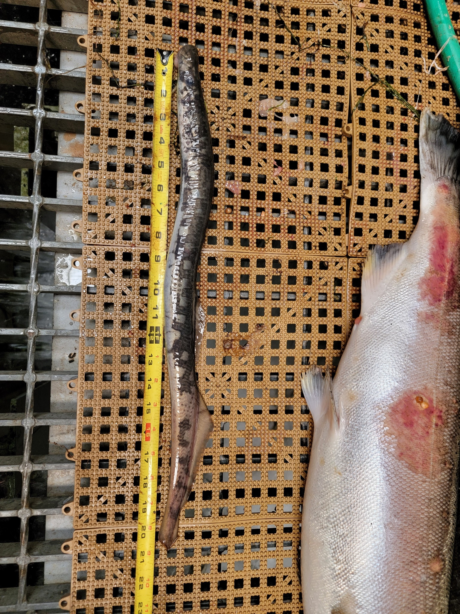
In the afternoon of 05 September, Columbia River Inter-Tribal Fish Commission (CRITFC) Biologists notified Bonneville Project Biologists of one Pacific Lamprey mortality and 16 other salmonid mortalities found on the Valve 15 trash rack in the Adult Fish Facility (AFF). The fish were all scanned for PIT tags, but none were found. Due to the advanced decay on the majority of these fish, some have been labeled as “salmonid” species. The fish were all examined thoroughly before being returned to the river.
#1
- Species – Pacific Lamprey (Entosphenus tridentatus)
- Origin – Unknown
- Length – 53.3 cm
- Marks and tags – None
- Marks and Injuries found on carcass – General decay
- Cause and Time of Death – Unknown
- Future and Preventative Measures – None

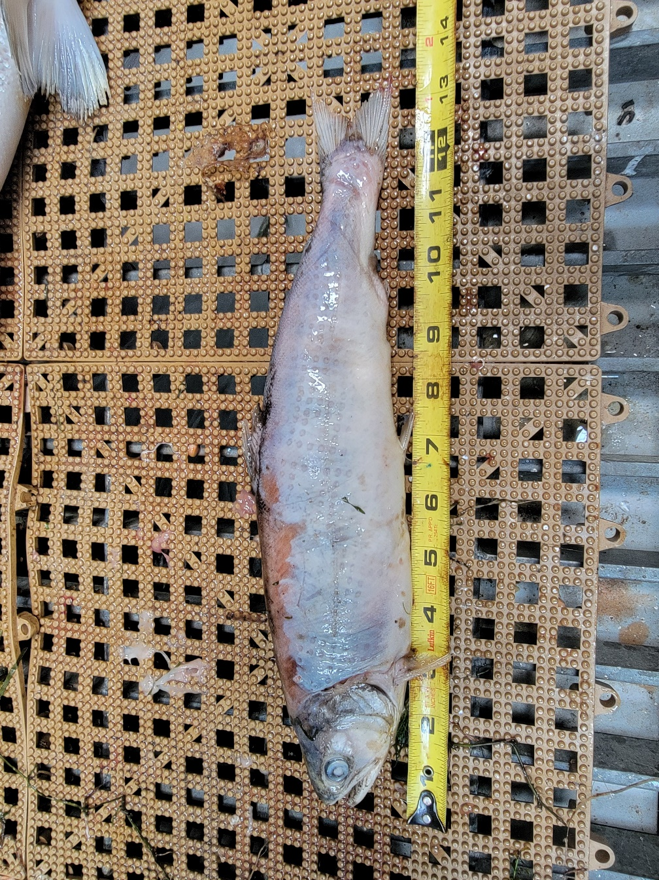
#2
- Species – Juvenile Salmonid (Oncorhynchus spp)
- Origin – Unknown
- Length – 33.7 cm
- Marks and tags – Adipose fin clip, no PIT tags
- Marks and Injuries found on carcass – General decay.
- Cause and Time of Death – Unknown
- Future and Preventative Measures – None

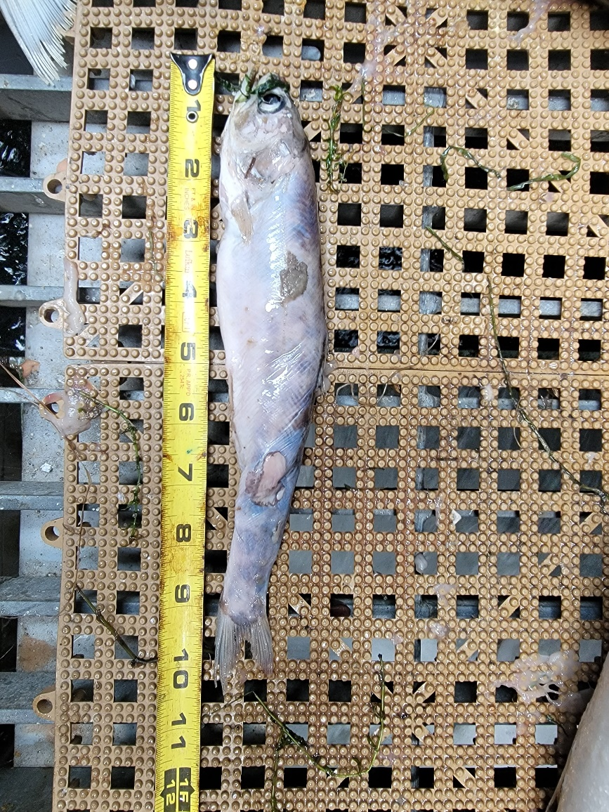
#3
- Species – Juvenile Salmonid (Oncorhynchus spp)
- Origin – Unknown
- Length – 26.7 cm
- Marks and tags – Adipose fin clip, no PIT tags
- Marks and Injuries found on carcass – General decay.
- Cause and Time of Death – Unknown
- Future and Preventative Measures – None
#4
- Species – Coho Salmon (Oncorhynchus kisutch)
- Origin – Unknown
- Length – 75.9 cm
- Marks and tags – Adipose fin clip, no PIT tags
- Marks and Injuries found on carcass – Advanced decay.
- Cause and Time of Death – Unknown
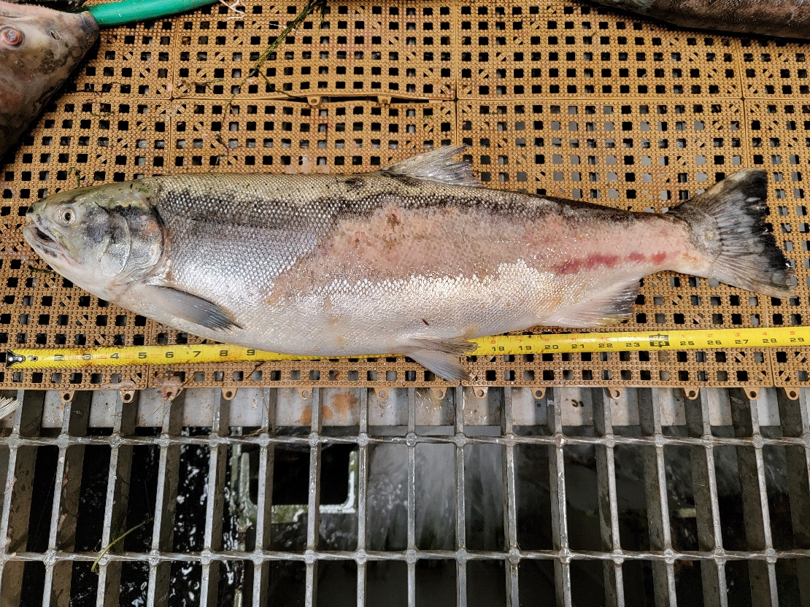
- Future and Preventative Measures – None
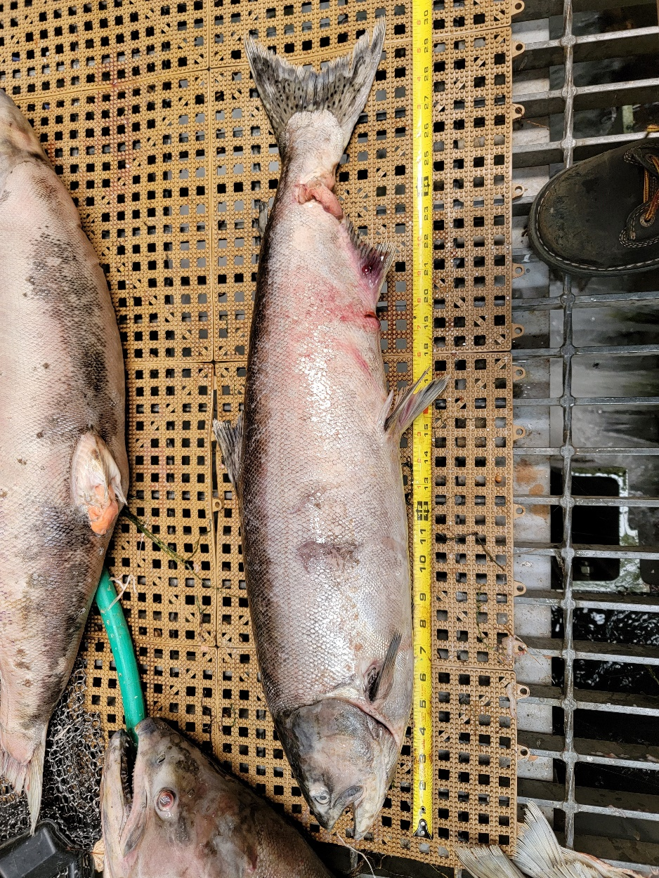
#5
- Species – Chinook Salmon (Oncorhynchus tshawytscha)
- Origin – Unknown
- Length – 77.5 cm
- Marks and tags – No PIT tags
- Marks and Injuries found on carcass – Advanced decay, lacerations, bloating, descaling.
- Cause and Time of Death – Unknown
- Future and Preventative Measures – None
#6
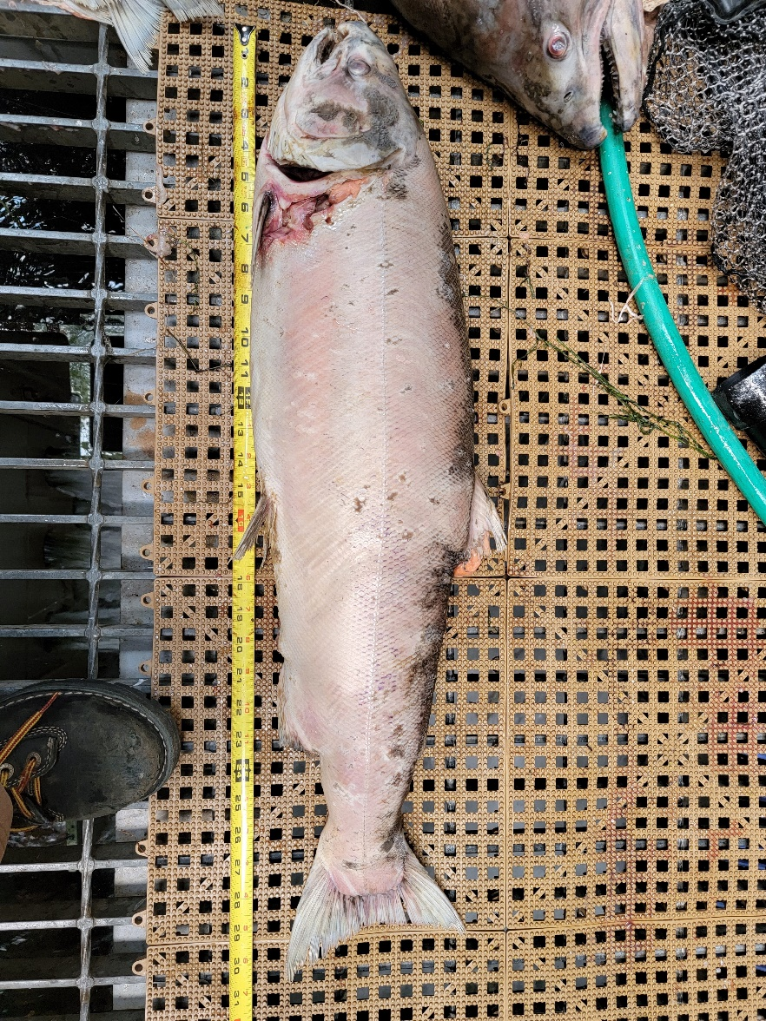
- Species – Salmonid (Oncorhynchus spp)
- Origin – Unknown
- Length – 77.5 cm
- Marks and tags – Adipose fin clip, no PIT tags
- Marks and Injuries found on carcass – Advanced decay, discoloration, descaling.
- Cause and Time of Death – Unknown
- Future and Preventative Measures – None
#7
- Species – Salmonid (Oncorhynchus spp)
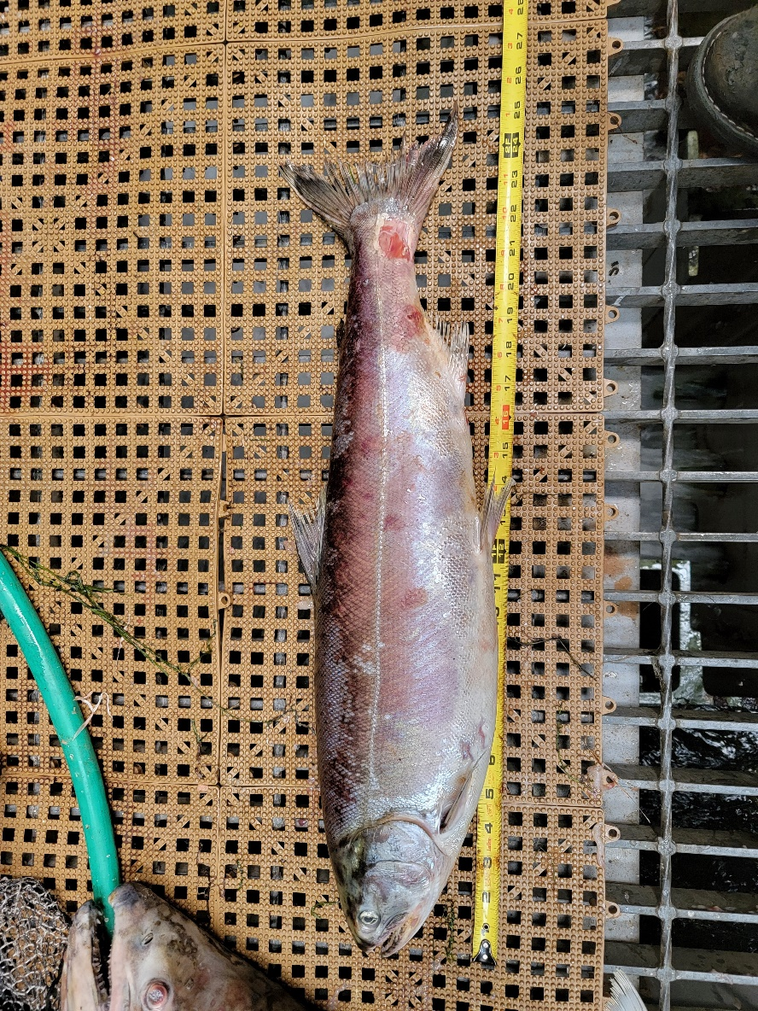
- Origin – Unknown
- Length – 63.5 cm
- Marks and tags – No PIT tags
- Marks and Injuries found on carcass – General decay, discoloration, hemorrhaging.
- Cause and Time of Death – Unknown
- Future and Preventative Measures – None
#8
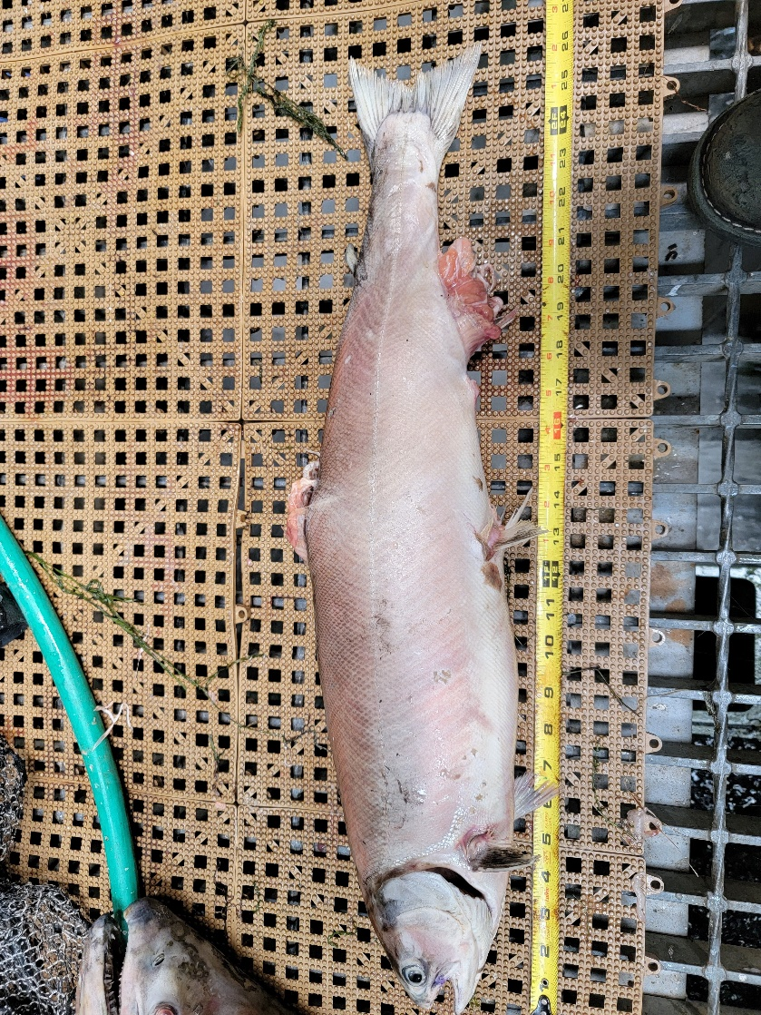
- Species – Salmonid (Oncorhynchus spp)
- Origin – Unknown
- Length – 66.8 cm
- Marks and tags – No PIT tags
- Marks and Injuries found on carcass – Advanced decay, hemorrhaging, descaling.
- Cause and Time of Death – Unknown
- Future and Preventative Measures – None

#9
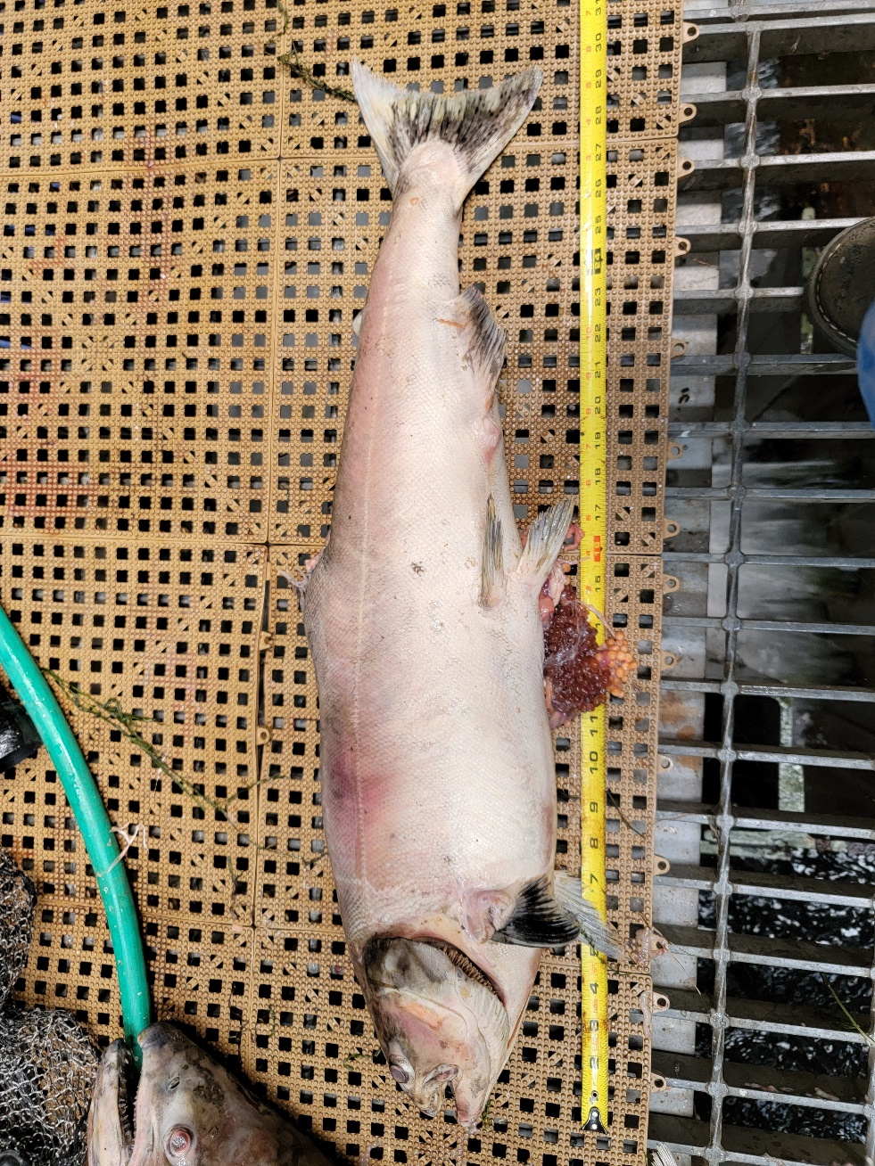
- Species – Chinook Salmon (Oncorhynchus tshawytscha)
- Origin – Unknown
- Length – 73.9 cm
- Marks and tags – No PIT tags
- Marks and Injuries found on carcass – Advanced decay, lacerations, discoloration, descaling, hemorrhaging.
- Cause and Time of Death – Unknown
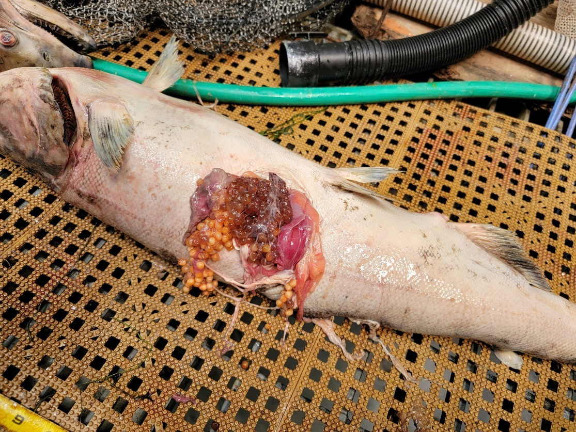
- Future and Preventative Measures – None
#10
- Species – Salmonid (Oncorhynchus spp)
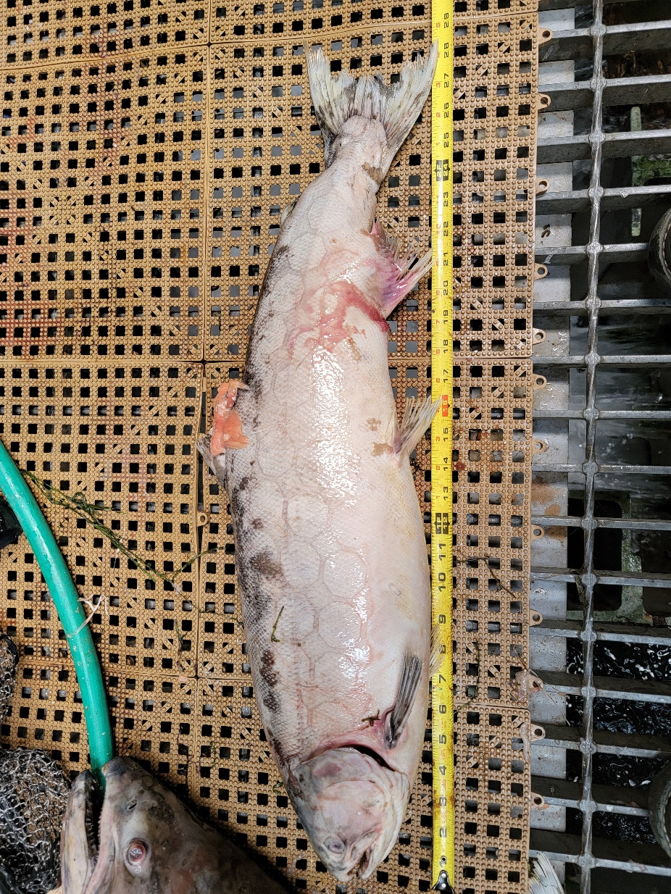
- Origin – Unknown
- Length – 73.2 cm
- Marks and tags – No PIT tags
- Marks and Injuries found on carcass – Advanced decay, discoloration, hemorrhaging, descaling.
- Cause and Time of Death – Unknown
- Future and Preventative Measures – None
#11
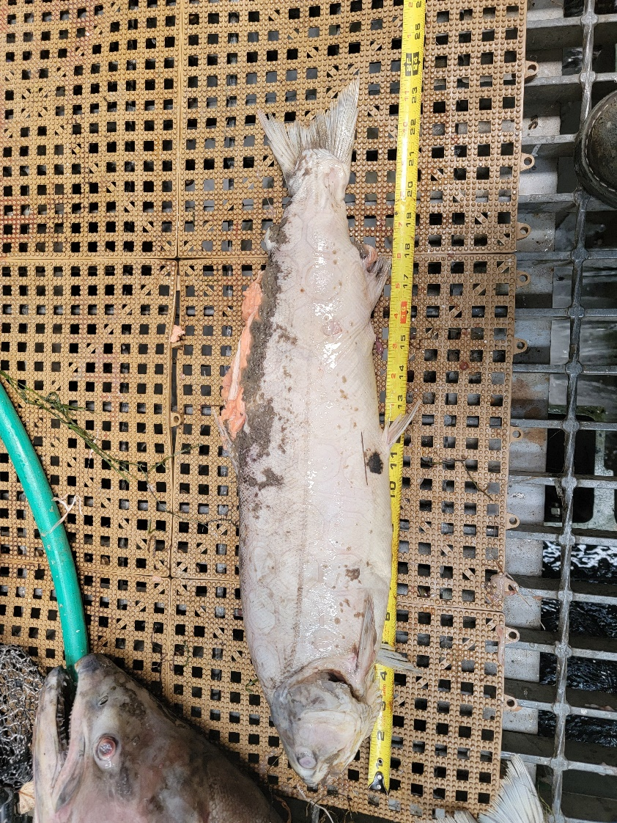
- Species – Salmonid (Oncorhynchus spp)
- Origin – Unknown
- Length – 59.7 cm
- Marks and tags – Adipose fin clip, no PIT tags
- Marks and Injuries found on carcass – Advanced decay and rot
- Cause and Time of Death – Unknown
- Future and Preventative Measures – None

#12
- Species – Salmonid (Oncorhynchus spp)
- Origin – Unknown
- Length – 73.9 cm
- Marks and tags – No PIT tags
- Marks and Injuries found on carcass – Advanced decay, discoloration, hemorrhaging, descaling.
- Cause and Time of Death – Unknown
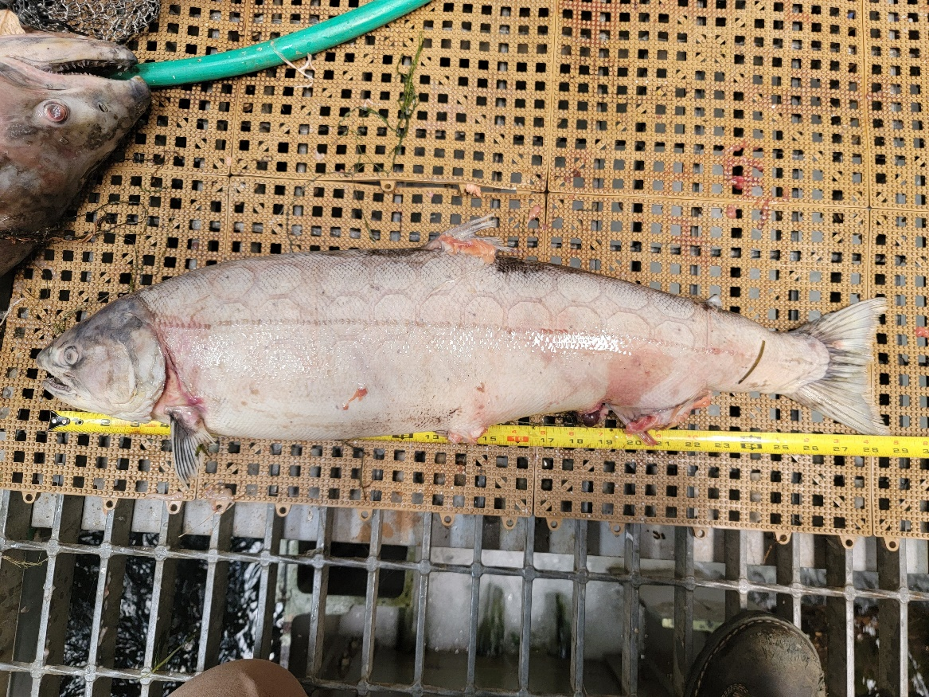
- Future and Preventative Measures – None
#13
- Species – Salmonid (Oncorhynchus spp)
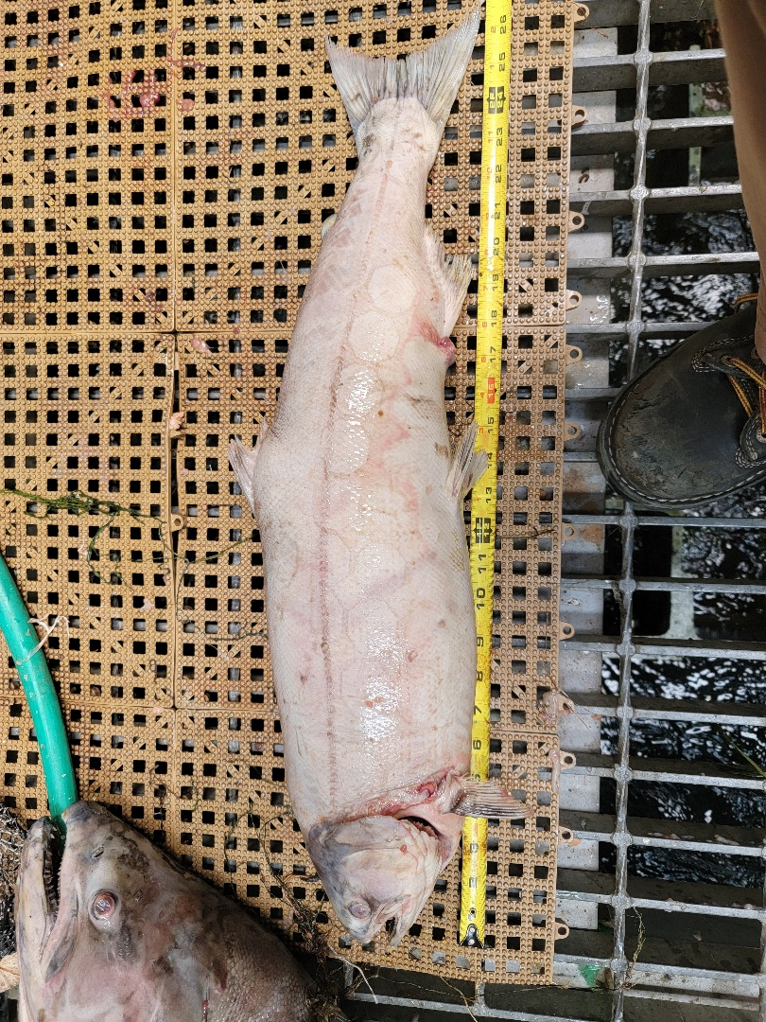
- Origin – Unknown
- Length – 67.3 cm
- Marks and tags – No PIT tags
- Marks and Injuries found on carcass – Advanced decay, discoloration, descaling.
- Cause and Time of Death – Unknown
- Future and Preventative Measures – None
#14
- Species – Salmonid (Oncorhynchus spp)
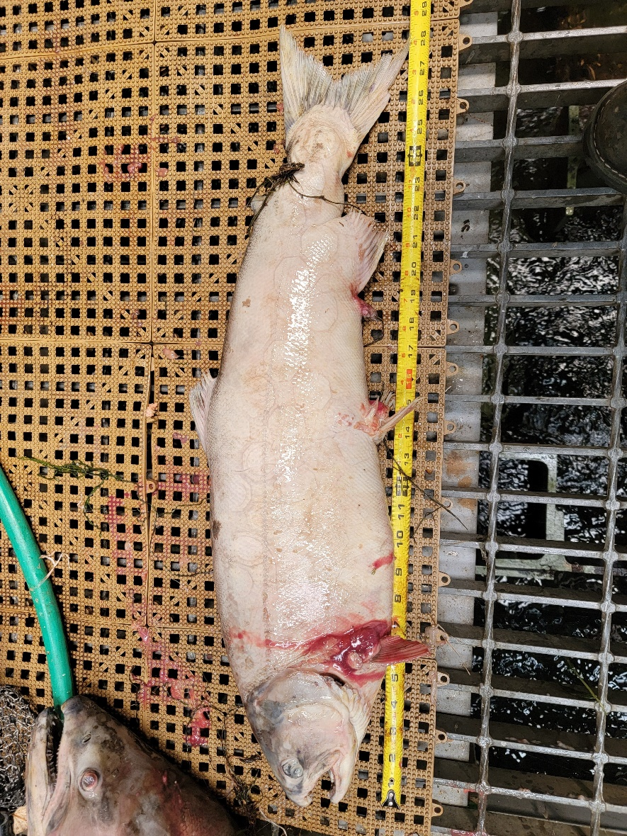
- Origin – Unknown
- Length – 73.7 cm
- Marks and tags – No PIT tags
- Marks and Injuries found on carcass – Advanced decay, hemorrhaging, discoloration, descaling.
- Cause and Time of Death – Unknown
- Future and Preventative Measures – None

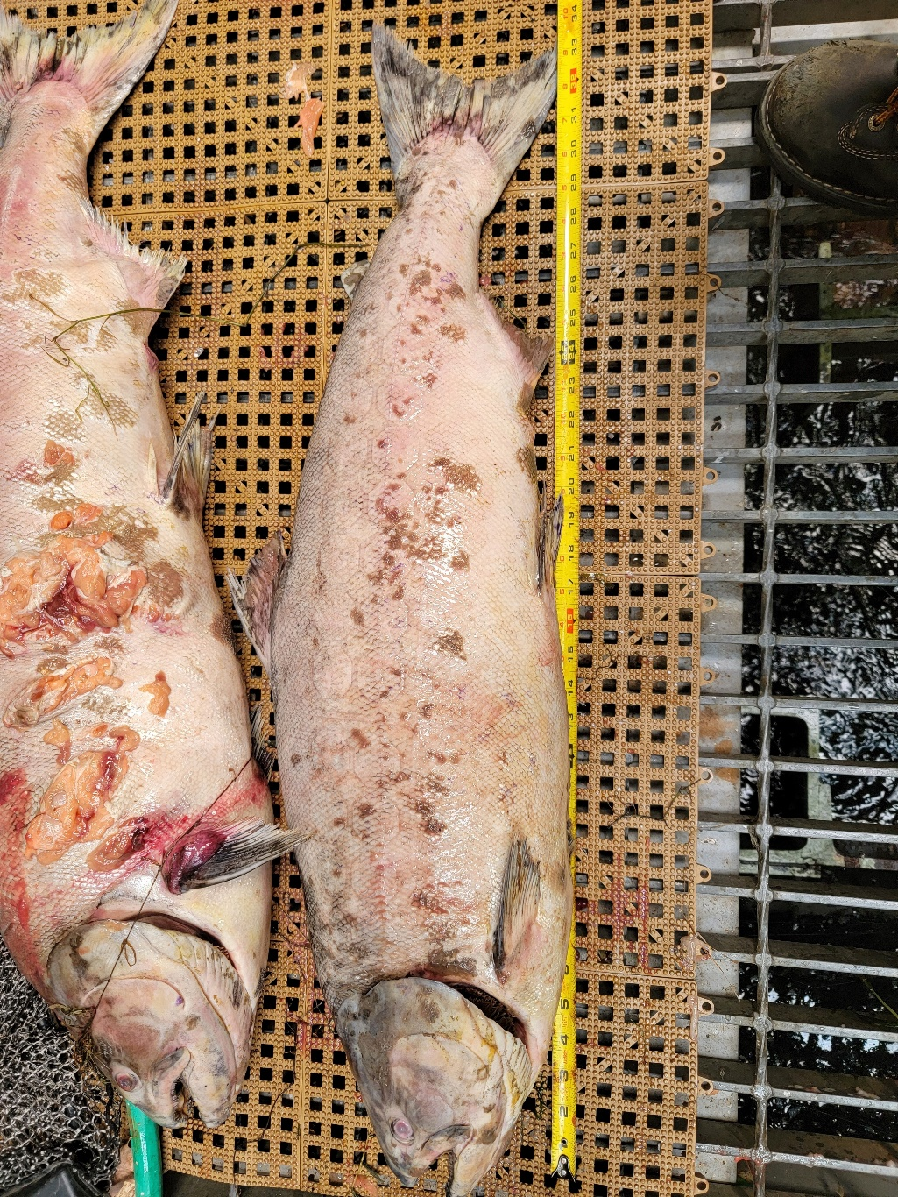
#15
- Species – Chinook Salmon (Oncorhynchus tshawytscha)
- Origin – Unknown
- Length – 83.8 cm
- Marks and tags – No PIT tags
- Marks and Injuries found on carcass – Advanced decay, discoloration, descaling.
- Cause and Time of Death – Unknown
- Future and Preventative Measures – None
#16
- Species – Chinook Salmon (Oncorhynchus tshawytscha)
- Origin – Unknown
- Length – 93.5 cm
- Marks and tags – No PIT tags
- Marks and Injuries found on carcass – Advanced decay, large hemorrhages, discoloration, descaling.
- Cause and Time of Death – Unknown
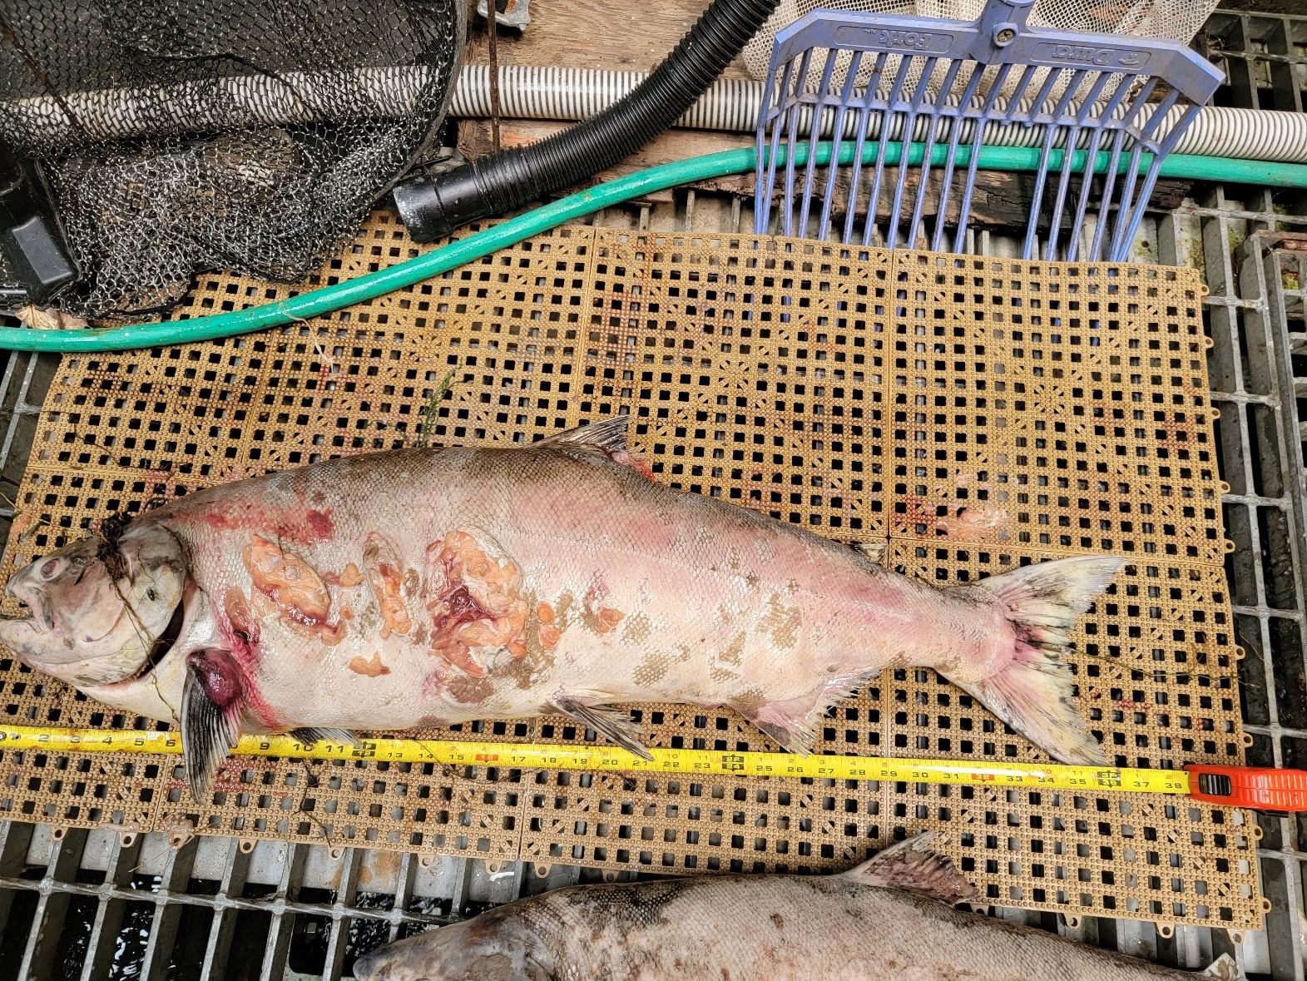
- Future and Preventative Measures – None

#17
- Species – Coho Salmon (Oncorhynchus kisutch)
- Origin – Unknown
- Length – 76.2 cm
- Marks and tags – Adipose fin clip, no PIT tags
- Marks and Injuries found on carcass – General decay.
- Cause and Time of Death – Unknown
- Future and Preventative Measures – None
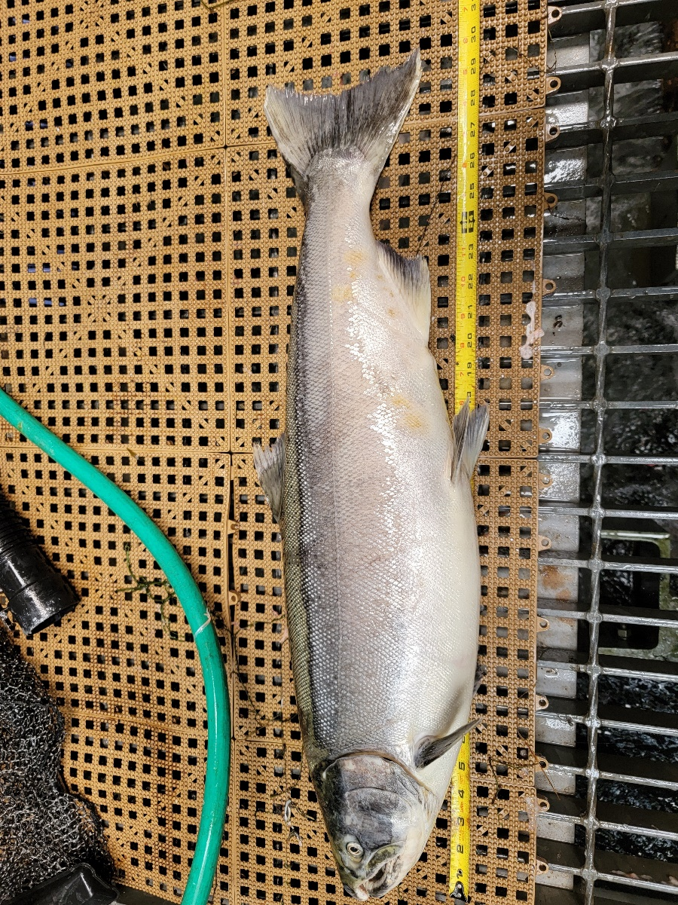

Sincerely,
Bonneville Project Fisheries

